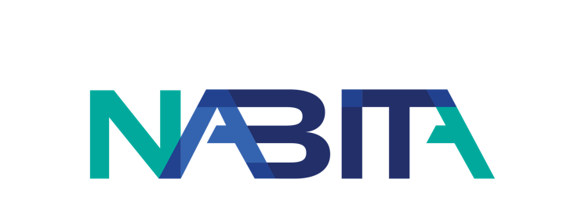
Date
From: [Your Name]
To: [Recipient Name]
Re: Request to Attend the 2022 National Association for Behavioral Intervention and Threat Assessment (NABITA) Annual Conference
Dear [Recipient Name],
I would like to attend the 2022 NABITA Annual Conference taking place at the Palm Beach County Convention Center from November 14 –November 16, 2022. Attending this Conference will be a valuable investment in my professional development.
This Conference will enable me to attend educational sessions that are directly applicable to my work as {your title}. NABITA offers four tracks at their Conference: BIT Operations, Case Management, and Safety and Threat Assessment. As an attendee, I will have the choice to attend sessions aligned with one track to receive targeted content in a specific of interest, or choose to move between sessions across multiple tracks to receive content in all areas.
NABITA can have over 300 attendees at their events, and their Annual Conference is the leading conference in the field of behavioral intervention, threat assessment, and case management. Since there are so many professionals that also want to take advantage of NABITA’s content at the Conference, this would be an opportunity to directly interact with other professionals in the field, share resources, and network.

NABITA is committed to making schools and workplaces safer environments where development, education, and caring intervention are fostered and encouraged, and where professionals from multiple disciplines can come together for mutual support and shared learning. The opportunity for me to gain knowledge in specific areas, develop better contacts, and share best practices makes my attendance at the 2022 NABITA Annual Conference an investment that broadens my ability to assist {your organization} in becoming a safer environment.

Sincerely,
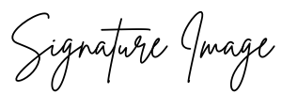
[Name]
[Title]

