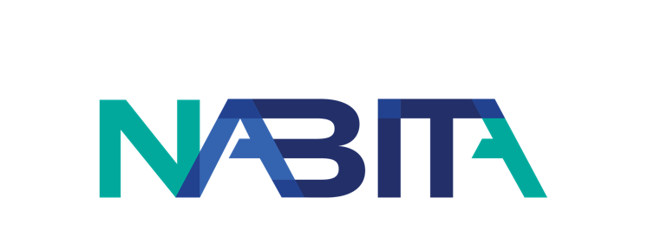
Date
From: [Your Name]
To: [Recipient Name]
Re: Request to Attend the 2023 National Association for Behavioral Intervention and Threat Assessment (NABITA) Case Management Summit
Dear [Recipient Name],
I would like to attend the 2023 NABITA Case Management Summit taking place at Belmont University in Nashville, TN from June 27-29, 2023. Attending this event will be a valuable investment in my professional development.
This Summit will enable me to attend educational sessions that are directly applicable to my work as {your title}. The Summit is a unique event designed to provide participants with the skills and knowledge needed to implement case management services. The presenters will deliver an overview of high-impact case management practices, as well as focus on the application of case management techniques with unique populations.
NABITA can have over 300 attendees at their events, and their Case Management Summit is ideal for administrators in either a full-time case management role, or in a position where case management services are part of their overall job duties. Since there are so many professionals that also want to take advantage of NABITA’s content at the Summit, this would be an opportunity to directly interact with other professionals in the field, share resources, and network.

NABITA is committed to making schools and workplaces safer environments where development, education, and caring intervention are fostered and encouraged, and where professionals from multiple disciplines can come together for mutual support and shared learning. The opportunity for me to gain knowledge in specific areas, develop better contacts, and share best practices makes my attendance at the 2023 NABITA Case Management Summit an investment that broadens my ability to assist {your organization} in becoming a safer environment.

Sincerely,
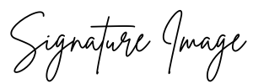
[Name]
[Title]

